OUR SOLUTION TO ZERO HUNGER

Team Searchbox

Ankita Swain

Basant Xaxlo

Shaikh Golam Tabrez

Tanmaya Kumar Naik

**Abstract**

In this paper we provide our solution to “ZERO-HUNGER GDSC HACKATHON 2023” . The model describes a 3-block model system that can linearly interact and has a verification system for fake accounts. Food wastage is a significant problem worldwide, with an estimated one-third of all food produced globally being wasted or lost every year. This amounts to approximately 1.3 billion tons of food that is never consumed, even as millions of people suffer from hunger and malnutrition. By taking a small step to get these leftover foods into the hands of those in need, this method will aid in saving the lives of those in need. To put this concept into practice, a smartphone application is suggested to be created. This application's job is to gather leftover food from different people and deliver it to those in need. One click will be all that is needed to disperse the gathered food to the designated location. Flutter was used to create the app, and Firebase was employed to create the back end. This method will assist those needy people by a small step of delivering the leftover food to them.

**1 Introduction**

In India, where up to 40% of all food created is thought to be lost or wasted annually, food wastage is a serious issue. This translates to an astounding 67 million kilos of food wasted each year.

In India, food is wasted from farm to fork at every point in the food supply system. Significant losses during harvesting, transportation, and storage are a result of inadequate infrastructure and storage facilities, especially for perishable products like fruits and vegetables. Large amounts of food are wasted in homes, restaurants, and other food service places, which is another factor in the behavior of consumers.

There are several detrimental societal, economic, and environmental effects of India's food waste issue. It wastes important resources like electricity, water, and land while also causing food insecurity and malnutrition. Additionally, it signifies a sizable financial loss for consumers, businesses, and farmers.

There are a number of initiatives being carried out to address the issue of food waste in India, including efforts to enhance the infrastructure for food storage and transportation, encourage better agricultural practices, and lessen domestic food waste through education and awareness campaigns.

In addition, there are numerous groups and charities that labor to assemble and distribute extra food to those in need, assisting in the fight against food waste and food insecurity in the nation. The main role of our model is this will satisfy almost every basic feature of a “leftover food distribution system” which are collection, sorting, storage, distribution, tracking, education and, education and awareness of the extra food to make this task easy and efficient.

A leftover food distribution system typically has the following basic features:

1. Collection: The system involves the collection of surplus or leftover food from different sources such as restaurants, caterers, supermarkets, and other food establishments.
2. Sorting: The collected food is then sorted and classified based on their type, quality, and shelf life. This is done to ensure that only the safe and consumable food items are distributed.
3. Storage: The sorted food items are stored in appropriate conditions to maintain their freshness and quality until they are distributed.
4. Distribution: The food is then distributed to organizations or individuals in need such as food banks, shelters, and charities. The distribution can be done through different channels such as pick-up, delivery, or drop-off.
5. Tracking: The system tracks the amount and type of food collected, stored, and distributed to ensure proper management and minimize waste.
6. Education and awareness: The system also includes education and awareness programs to inform people about the importance of reducing food waste and the benefits of leftover food distribution.

Overall, a leftover food distribution system aims to reduce food waste, address food insecurity, and promote sustainable practices.

**2 Problem Statement**

There is a food scarcity for the slums of our local region. There is no current proposition to distribute food for them.

**3 Model explanation**

Our model mainly consists of three blocks: Donor’s block, Distribution block and Booth block. Basically the food is collected in the donors block and is distributed by the booth block setup at different locations of the region. The distribution block transports the food from the donor block to the booth block.

**3.1 Donate**

Our major food benefactors are restaurants, banquet halls, hostels and other places where there is huge production of food. In these places, there is also a large amount of food which remains as leftovers. To utilize the leftover food, we have designed our application. We have a feature where the donor can inform us about the remaining food. Donors could inform us about the location, quantity and the time upto which the food can be kept preserved. For verification, we have asked the donor to upload a photo of the food.

**3.2 Distribution**

In this phase, the food donated by the benefactors has to be distributed. Our distributors will now choose their location and the point where they are supposed to be going. After selecting continue, our app will show the distribution points in line. The distributor has to choose one, pick up food from the chosen point and then supply it to that food booth.

**3.3 Food booth**

To distribute the food to the needy ones, we need to set up food booths. Food booths can’t be set up everywhere, we aim to set up food booths at nearby slum places or where there are the utmost needy ones. After setting up the food booth, the user has to constantly record the current stocks he has and the number of stocks he still wants. This depends on the number of people present in that booth over that particular time. If at any time due to any reasons, the user does not update us regarding the stocks then there will be no supply of food to that particular booth.

**3.4 Contributors**

To increase the motive of food donation, we have made a page for our contributors to show how much they have contributed over a time interval. A portfolio will be created for each of our benefactors. We will constantly update the number of stocks contributed by that contributor. This will help to promote the services provided by our contributors and will also motivate them to donate more and more.

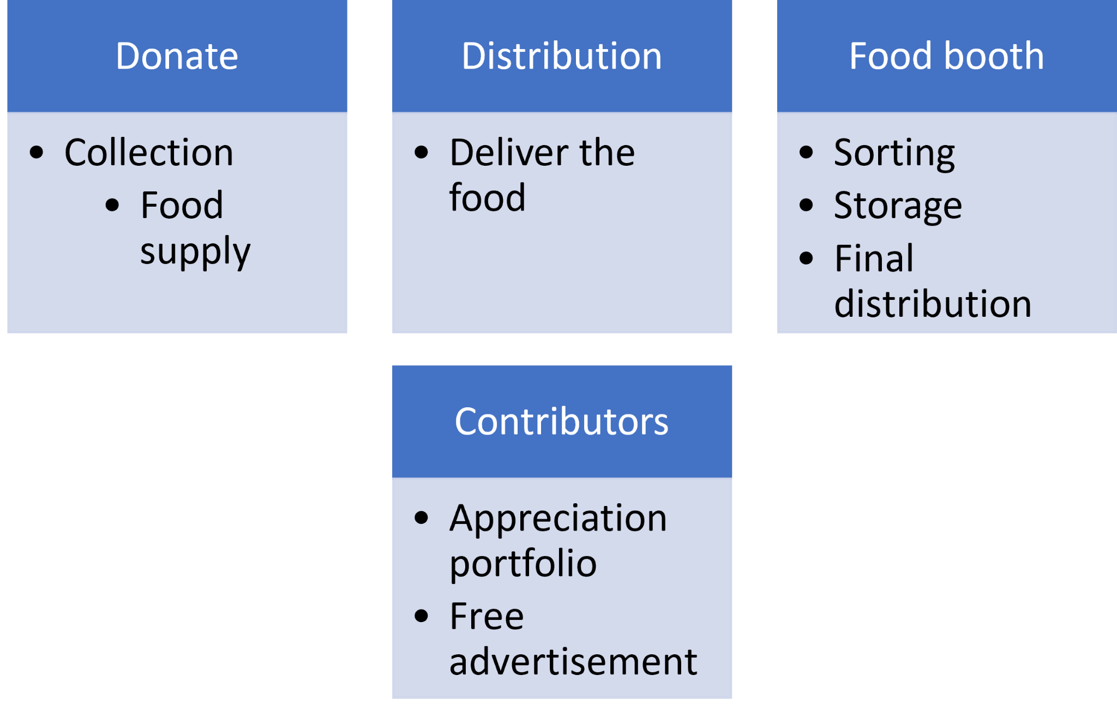

**4 Challenges**

1. **Donate**:
   1. **Donor Awareness**: One of the main challenges in the donor part of leftover food distribution systems is raising awareness among potential donors about the importance of donating their excess food. Many individuals and businesses may not be aware of the scale of food waste or the potential benefits of donating leftover food.
   2. **Logistics and Convenience**: It takes time and effort on the part of the donor to donate extra food, which may be an obstacle. The food may need to be packaged and stored in a special way, or donors may need to make arrangements for collection or delivery. By offering donors convenient donation choices and easing their logistical burden, distributors can aid in resolving this issue.
   3. **Availability of Donors:** The availability of food donors can be a challenge in leftover food collection. Donors may have unpredictable schedules or may not have enough leftover food to donate. Distributors may need to invest in outreach and engagement strategies to build relationships with donors and ensure a consistent supply of leftover food.
   4. **Collection Logistics**: Collecting leftover food from multiple donors can be challenging, especially if the donors are located in different geographic areas or have different schedules. Distributors must develop efficient collection routes and scheduling strategies to minimize travel time and maximize the amount of food collected.
2. **Distribution**:
   1. **Food Safety and Quality**: When collecting leftover food, food safety and quality are top priorities because the food may have been improperly kept or may have gone bad. Distributors are responsible for making sure the food is wholesome and adheres to all relevant food safety laws.
   2. **Transportation Costs**: Transportation costs can be a significant challenge in leftover food distribution systems, especially if the distribution area is large or the food needs to be transported over long distances. These costs can include fuel, vehicle maintenance, and insurance, among others.
   3. **Capacity Limitations**: Another challenge is capacity limitations. Distributors may have limited capacity to transport and store leftover food, which can limit the amount of food that can be distributed. This can be particularly challenging during periods of high demand or when there is an excess of leftover food.
   4. **Temperature Control**: Temperature control is critical in the transportation of leftover food, especially if it is perishable. Distributors must ensure that the food is transported at the proper temperature to prevent spoilage or contamination. This may require the use of specialized vehicles or equipment
3. **Food booth**:
   1. **Timing and Availability**: In order to prevent food from spoiling or becoming unfit for consumption, distributors must make sure that leftovers are distributed promptly and effectively. To make sure that the food is accessible when and where it is needed, careful coordination and planning are required.
   2. **Access to Recipients**: Accessing prospective recipients of leftover food may also be difficult for distributors, especially in places with poor transportation infrastructure or where food distribution is restricted. This can make it challenging to deliver meals to those who need it the most.
   3. **Legal Liability**: If the food they deliver results in illness or injury, distributors may be held liable in court. Distributors must make sure the food they distribute is secure and adheres to all relevant food safety laws in order to reduce this danger.

**5 Conclusion**

Thus this model will help reduce food wastage and food security. By collecting, sorting, storing, and distributing leftover food, the system ensures that safe and consumable food items are put to good use instead of being wasted. Also, the food depicted regions will get recognized and be considered by the government. The NGOs and volunteers' reach can increase their influence among the citizens and the government, and may also involve partnerships and collaborations between various organizations and stakeholders, such as food banks, charities, government agencies, and food businesses. These partnerships can help to ensure that the system operates effectively and efficiently, and that the food is distributed to those who need it the most. Overall, a well-designed and well-implemented leftover food distribution system can have multiple benefits, including reducing food waste, addressing food insecurity, promoting sustainable practices, and having positive environmental impacts.

**6 References**

1. Modeling the causes of food wastage in Indian perishable food supply chain. 2016
2. Food Bank Management System - Feeding Humanity Through Mobile App. 2020